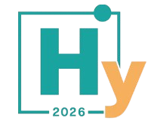

Supervisor Approval Form
European PhD Hydrogen Conference (EPHyC 2026)
Trondheim, Norway from 1–3 June 2026

This form confirms that the undersigned student is an active PhD candidate and has the approval of their academic supervisor to present research work at the European PhD Hydrogen Conference 2026.

PhD Student Name:

Institution / University:

PhD Project Title / Topic:

Supervisor Name:

Supervisor Email:

Supervisor Signature:

Date:

